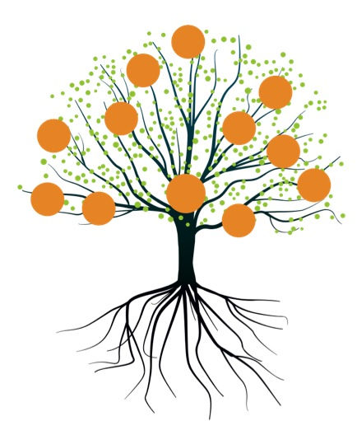
Reaching the Poorest of the Poor
A Special Initiative of the HiMaT Indigenous
Leadership and Development Program - Pakistan
Introduction
As most people who work in the field of comprehensive poverty alleviation already know, reaching and changing the lives of the poorest of the poor is a very elusive and difficult goal to achieve.
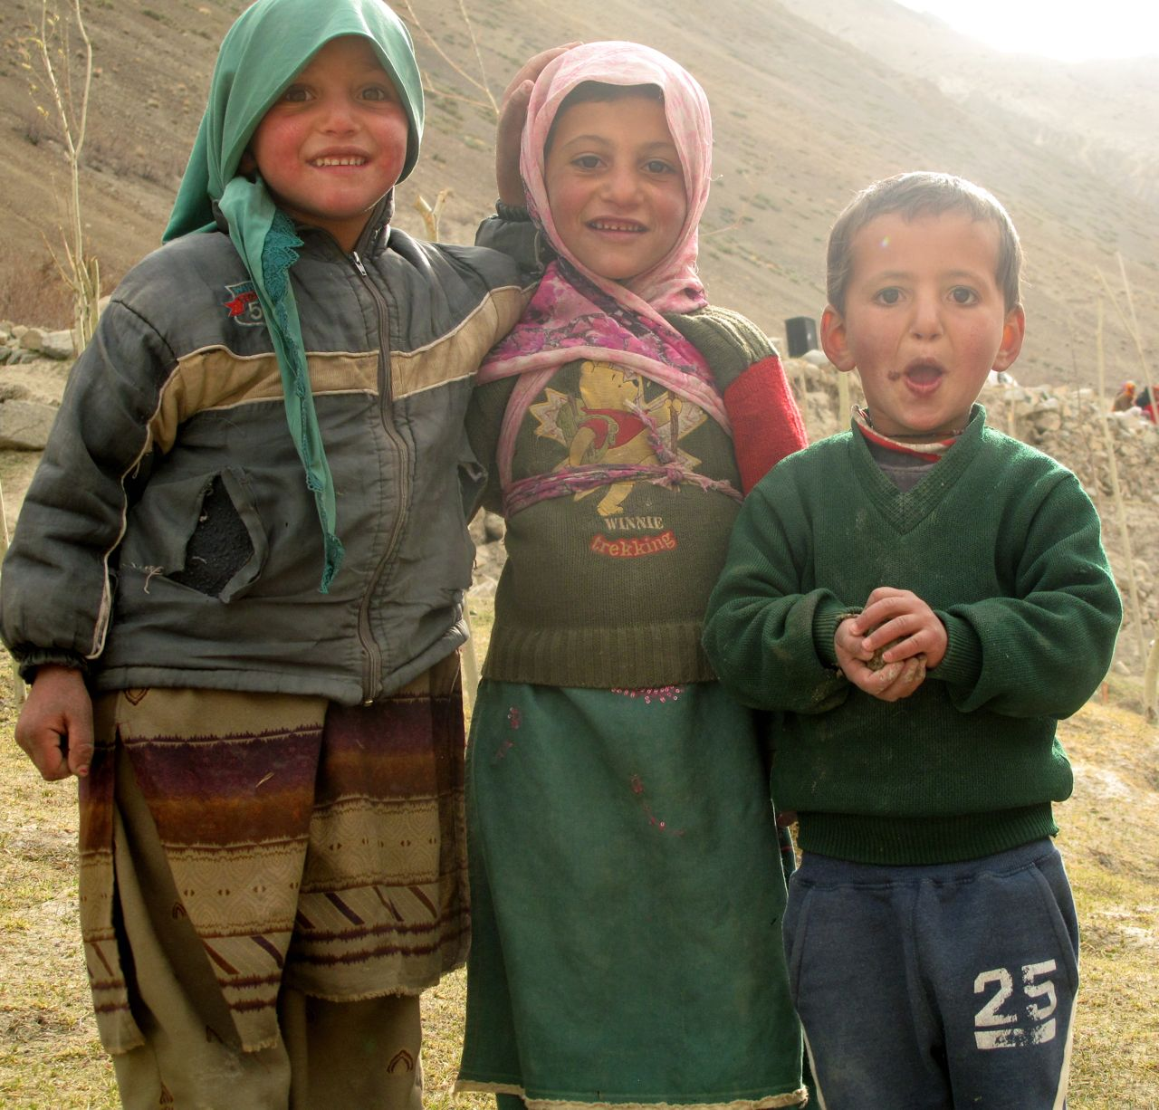
HiMaT works with 116 villages in 9 clusters, and between 70-95% of the people in those communities are living well below the poverty line. Indeed more than half of the households are so poor that they need food aid to survive for seven or more months of the year.
But within these communities, there is a smaller number of what people in the region refer to as “ultra poor”. These are the very poorest households, usually women-led, and very often living with the aftermath of a catastrophe (such as flood damage, sickness or death of a spouse, etc.). Often these households also have very low levels of literacy and marketable skills, and paralyzing levels of despair and hopelessness.
HiMaT Response

The mission of HiMaT is not “to get people out of poverty”. The mission is “to build the capacity of people and communities so they can get themselves out of poverty, and stay out”.
The HiMaT team has undertaken a special project with the following goals.
- To identify the poorest of the poor (or ultra-poor) households in our target villages.

- To engage those households as well as local institutions (women’s councils, village councils, area councils, religious institutions) in a learning and action journey that will lead selected families out of poverty.

Twenty-five (25) of the poorest households in 3 clusters were selected in consultation with local communities. These households will receive the same targeted interventions the HiMaT was directing to whole communities: a) measures to ignite and fan the flame of hope and belief in the possibility of change; b) capacity building through intensive training, coaching and mentoring focused specifically on learning what is needed to succeed in the journey out of poverty; c) seed grants and access to credit, as well as technical support to develop a successful business enterprise; and d) linking the family to a strong social/community support network.

Additionally, these families will receive (very small) income support to cover school fees and health insurance and to ensure food security until the increased family income from enterprise activities can allow the gradual phase out this assistance (this with the genuine help of local religious institutions).
Our philosophy in this venture, which we shared with the partner families, is this: We understand that to be able to climb the ladder out of poverty you need to be able to reach the bottom rung and we will help you to get to the ledge and to reach the bottom rung. But you will have to climb the ladder yourself. That no one else can do but you.”
Why Are We Doing This?
To learn. We recognized that the only way to learn how to help the poorest of the poor is to engage with the problem and stay engaged until we are fairly sure we understand what is really needed. Our starting point is twenty-five families in three of the present clusters. We also recognize that it’s not only we that need to learn. Local leaders and institutions value mutual and ensuring a reasonable life for all, but all of us need to learn how to do bring this about.
A few generations ago, everyone was more or less on the same economic level. But the introduction of the market economy since the 1960s has driven a wedge between those who have and those who don’t. That wedge has only widened over time, until now, when the area is experiencing major post-disaster trauma and disruption, it is clear that communities need to re-learn how to really support each other.
Profiles
The pages that follow profile fifteen women, eight from Hussani in Gojal, an area that was hard hit by the Attabad landslide.
Reading their stories will give you a starting point for understanding more intimately the challenge of helping the poorest of the poor to help themselves.
Reflection
We share this report with you, our supporters and friends, so that you can put faces on the members and stories we tell you about in our reports. HiMaT is working with whole communities in poverty, but we are also making a serious effort to reach and assist the poorest of the poor, which is not easy to do, especially if your goal is to move beyond charity to development.
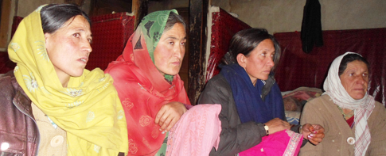
Stories of Eight Most-deserving Women in Hussaini, Gojal
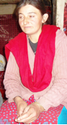
What follows are the profiles of eight women heads of households in Hussani. These eight deserving women are the primary bread earners of their families and they are struggling against incredible difficulties just to survive. You will hear them talk about their efforts to get enough food, to educate their children, to help other family members, and you will get a glimpse into their world as they make courageous efforts to face social and economic barriers in order to upgrade their standard of living and escape the trap of poverty.
These profiles were compiled by Didar Ali, the Capacity Building Coordinator for the HiMaT Indigenous Leadership and Development Program based at the Karakorum Area Development Organization (KADO) in Aliabad. The interview session was coordinated by members of the Village Focus Humanitarian Assistance Committee (Farida Azam and Bibi Nasab). They are committed to the development of these women and to support our activities and other organizations.
Malika Rehmat W/O Rehmat Baig
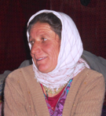
I got married in 1984 with a young man. He was working in the Pakistan army. We had a good family life. We had a baby boy that increased our happiness. Suddenly this happiness turned to misery when my husband was infected with a bone disease. Every year he became weaker than the previous one. We spent all that we had on his treatment, until there was nothing left for other expenses at home. Finally doctors had nothing more to offer us. In 1990 he became disabled.
We have three sons. The most difficulty in life remains to provide proper food for the children and send them to school for a quality education.
With several years of struggle we were able to get 1000 Rs ($10) pension each month from the Army for his service. We have a very little piece of cultivatable land. We can only make a small amount of profit to purchase some food necessities, but that is not enough for 5 months. School fees and uniforms for our children were also a priority. We were able to manage at the primary school level, but further education at college is not possible for us. My two elder sons quit their education due to financial barriers at the college level.
We cannot forget those days when our food store gets empty at the end of the winter season. We face many days of starvation. We could not tell our stories to other people.
I can work on sewing clothes, kitchen gardening and quilt making, but I don’t have much expertise in these skills to increase my family income.
If the small piece of land could be developed for a kitchen garden and some technical skills and know how would be given to me, I can promote kitchen gardening. This will be helpful for me to involve my family in the process and increase our income.
Bibi Salma W/O Hazir Aman
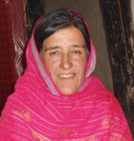
I have four children 10, 14, 17 and 20 years of ages respectively. We had a prosperous life and a good family income. Five years ago my husband got injured while loading heavy baggage on to a truck at the dry port (Sost). In the beginning he felt muscle pain. Later that pain didn’t get better and instead spread out all over his body. Every effort during the five years of continuous treatment in different hospitals, including the Aga Khan hospital in Karachi, were useless. Now life is very tough for me. I hardly manage to provide food for my children, and I could not support them to receive school and college education.
I tried my level best to support my daughter among other children. During these days I raised chickens and sold eggs in the market to pay her school fees. My elder son stopped education after the 10th grade. He could not continue due to our financial problems. Usually he goes to work as a laborer, and that helps us get medicine for my husband and food items for the kitchen.
I feel guilty when my daughter faced problems paying hostel and tuition fees for college. Her friends got admissions in good colleges and have made good progress in education. That situation mostly hurt her and she usually prefers to live in isolation.
Beside agricultural activities, one of my sources of income is raising chickens. With external help I can expand my activity into a small poultry farm, and this can help me to generate my family income. Another source of income is kitchen gardening, but most of the vegetables go to waste because the market is too far, and at the village level there is no one is ready to buy these products, because most of the people are producing for their own needs at the home level.
Bibi Anar W/O Muhammad Ali
My husband was disabled at birth. I was forced to marry with him when I was 13 years old. We have 5 children: one son and four daughters. We have very little cultivatable land. We can hardly grow some grain and store food for six months. The same situation applies to storing fodder for cattle. Agriculture is the only source of income to provide food for the whole family and to pay for their school tuition and uniforms.
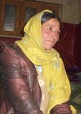
It has been difficult to provide proper education for my daughters and get them married into good families. After completing school education, luckily two of them got married. They are very happy with their families. Now I am seeking educational support for my younger daughter and my son for college education and this is my lifelong objective.
I spend many sleepless nights and days when we were facing food shortage at my home. We have taken a loan from the micro-finance bank. We also owe debts to the W/O and local shopkeepers that are still due from many years. This situation is creating more hurdles for me because the shopkeepers are not ready to provide more food items to us on credit.
I need additional skills that will help me to generate some more income. My only current source of income is kitchen gardening and livestock that help me and my family survive and hope for a better life.
Zareena Parveen W/O Sherbaz
I am an illiterate women. I didn’t know why I could not study in school. I got married in 2007 with an illiterate man. Agriculture is our primary source of income and secondly my husband works at the lakeside as a laborer to add some more money to our family income. I have two daughters. They are very young now. Their school expenses are now being met by our savings, but as they are grow up it will be difficult for me to meet their educational needs. Sherbaz has no skills that could help us to double our income.
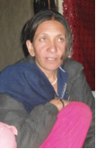
My plan is to increase our livestock, especially goats and sheep. This will enable me to get more milk and butter that I can sell in the market to add to my income. We also produce pulses (peas) and onions that my husband takes to the lakeside and sells in the temporary shops. If those shops close, this opportunity will close too.
If a group of farmers produce these crops in bulk, some of us could carry produce to down country. In this way we might be able to double our income.
Lal Jahan W/O Sher Bahadur Khan
My husband is physically week by birth. He was the only son of my elder uncle. When I was 14 years old, my uncle came to my parents for my engagement. I was not happy with this proposal, but my parents and brothers forced me to marry my cousin.
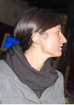
After two years of marriage, my father-in-law passed away. My mother-in-law could not bear the loss and she died after some months. I was too young and my husband was not physically sound. Our cultivatable lands were not enough to produce sufficient food and fodder for our needs. In that period my brother supported me financially, but he cannot support us forever because he has to support his family members too.
We spent many harsh days without food. I could not beg anything from my neighbours. I cried about my fortune and was very disheartened by my life. Several times I tried to commit suicide, but one of my close friends stopped me from this sin. She always was a source of encouragement in my life. Anyhow, my neighbours are very kind to us. They are helping us in many ways. Once there was a food crisis in the entire valley. We had nothing to eat. One of my neighbours shared a bag of flour with us that he kept for his own emergency use.
My brother told me to buy a spinning machine. I have little knowledge about how to spin wool. Once I have this machine in hand, it will help me to double my income. I am totally illiterate because of my parents were living at the last village in Chipursan. I never got a chance for school education. I was helping my parents in cattle rearing. Now I am thinking to utilize my skills to raise sheep and goats. I am looking for a good opportunity in this work. I can make money through this activity to support my children in their education.
Zulhaja W/O Muhammad Aziz
I have three daughters and two sons. My husband is sort of abnormal, but he can help us in agriculture activities and cattle rearing. We don’t have sufficient lands. We can hardly produce enough cereal crops to fulfill our requirements for a few months.
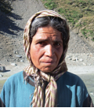
We don’t have any additional opportunity to increase our family income and support my children in their education. Most of them are going to school, and each day their school fees and other expenses are increasing beyond our capacity to pay. My elder son stopped his education after completing his 10th grade. We don’t have any source of income to support him in college education.
I am always worried about my daughters. They are growing up; their needs and expenses are increasing at the same level. We don’t have the capacity to fulfill their requirements.
I can only hope to increase our livestock to add some income. I need additional skills and support in husbandry and kitchen gardening.
Bibi Noqra W/O Sher Dil Khan
I am widow. I have one daughter and two sons. Eight years ago my husband passed away when my children were very young. We have sufficient cultivatable lands, but we don’t have the capacity to produce maximum crops that we can sell to increase our income. My priority remains to provide for my children. For many years survival was very difficult for me. I could hardly support my children in school education. As well, my sons have grown up. They left education and supported their sister. Last year she completed her Masters from Peshawar University, but my son went to Karachi for work and support himself to continue his education.
My elder son is unskilled. He got married last year. He continues to try to support me because now I am not able to work in the field and to rear cattle. My son and daughter-in-law need to gain skills and be engaged in livelihood activities that will enable us to generate sufficient income.
Shaem Sultana W/O Iqbal Aziz
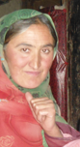
I have four children: three daughters and one son. My husband is a driver. This is the only source of income for the whole family. Most of the time he is not getting any work. In the beginning he spent all his savings and bought a used vehicle, but the condition of the vehicle was not good. He borrowed money from people and the bank for its maintenance, but it didn’t work. Nowadays, he is working with Chinese contractors, but his income cannot meet all our expenses and pay back the loans we have taken.
Besides these troubles, one of my daughters has a bone disease. We cannot afford to pay for doctors. She needs treatment at the initial stages. I have skills in handcraft, but I have problems with my eyesight. My doctor said, “You are suffering with color blindness that increases day by day.” I am worried for the future of my children if this situation remains for years.
Final Remarks (for now)
We are very grateful for the support and assistance of all of our donors and friends. Without all of you this important work could not be happening. As always, we welcome your questions, thoughts and suggestions.

The single most challenging critique of poverty alleviation programs worldwide is that they fail to effectively reach the poorest of the poor. This is true for many reasons. HiMaT is struggling to overcome the challenge.

